Lesson 3: Do all objects change shape or bend when they are pushed in a collision?

Previous Lesson | We explored colliding objects and recorded observations about changes in their motion and shape. We analyzed slow-motion videos of some of these collisions. We developed a model to represent what we know about energy transfer and forces occurring in collisions when we see changes in motion of objects, shape of objects, or damage to objects.
This Lesson  Investigation  1 day   | 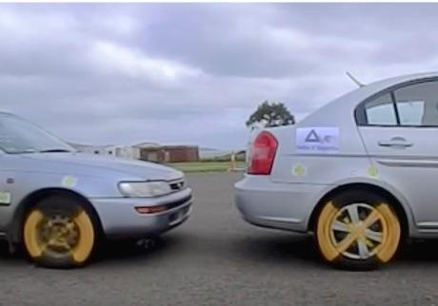Delta-V Experts | We make a claim about whether all solid objects bend or not when pushed during a collision. We analyze slow-motion videos, carry out an investigation with a laser and a mirror, and analyze a concrete joint load testing video. We use these sources of data to argue for whether our original claims are supported or refuted by the evidence.
Next Lesson | We will plan and carry out an investigation into the relationship of contact force applied and the amount of deformation that occurs in different materials. We will graph our data and compare our graphs to those from other materials tests. We will develop a model to explain and represent the elastic and nonelastic behavior of all solid objects in response to varying amounts of force applied to them.

BUILDING TOWARD NGSS  MS-PS2-1, MS-PS2-2, MS-PS3-1, MS-ETS1-2, MS-ETS1-3, MS-LS1-8   | What students will do  3.A Construct and revise a written argument using evidence from various sources of data (slow-motion videos, photos, and firsthand investigations) to support or refute the claim that all objects do bend or change shape when pushed in a collision.  What students will figure out  - All solid objects bend or change shape when pushed on in a collision and when other contact forces are applied to them.

Lesson 3 • Learning Plan Snapshot
Part | Duration |  | Summary | Slide | Materials
1 | 6 min |  | NAVIGATION  Recall from the previous lesson examples of objects that changed shape or bent during (or from) a collision and make predictions about whether all objects bend or change shape in collisions. Establish an initial claim about whether this happens to all objects when they are pushed in a collision. | A-B | Claim and Observations Organizer
2 | 5 min |  | ANALYZE VIDEO CASES  Analyze slow-motion videos for evidence of objects bending in a collision. Record observations and determine if observations support or refute the claims made. | C-H | Claim and Observations Organizer, computer, projector, video A: https://youtu.be/My1WOu3LOCM, video B: https://youtu.be/sVr6tVy7htU, video C: https://youtu.be/FYbn1WSWmQg
3 | 5 min |  | DISCUSS FINDINGS AND INTRODUCE CONTACT FORCE  Discuss observations from the videos and introduce the term contact force. Add contact force to the Word Wall. | I-J
4 | 12 min |  | PREDICTING AND TESTING OUR PREDICTIONS FOR APPLYING CONTACT FORCES TO A PIECE OF GLASS  Collect data on how laser light reflected off a surface (glass) is affected when an object is dropped onto the glass and when a static weight is placed on the glass. | K | Claim and Observations Organizer, Reflected Laser Investigation
5 | 4 min |  | MAKE PREDICTIONS AND ANALYZE CONCRETE LOAD TESTING PHOTOS  Poll the class on their initial predictions and show a timelapse video from load testing a concrete joint. Have students make observations to determine if this case supports or refutes their claim. | L-M
6 | 5 min |  | EVALUATE AND REVISE INITIAL CLAIMS  Evaluate and revise the claim made about objects changing shape and use this claim to make an argument about whether objects change shape when a force is applied. | N | Claim and Observations Organizer
7 | 8 min |  | NAVIGATION  Reflect on concrete double tee bridge joint findings and determine how we can test the amount of force needed to bend any object. | O-Q

End of day 1

Lesson 3 • Materials List
 | per student | per group | per class
Reflected Laser Investigation materials |  |  | - 1 rolling cart  - 1 ring stand  - 1 test tube clamp  - 1 laser pointer  - 1 clothespin  - optional: 1 box to raise the height of the ring stand  - 1 classroom lab table  - 1 sponge  - 3 2”x4” pieces of flexible stick-on mirror material  - 2 bricks  - 1 rectangular piece of glass (15” long x 8” wide)  - tape to secure glass to bricks  - 1 cup half-filled with rocks  - 1 golf ball  - chart paper  - tape  - 1 pencil or marker
Lesson materials | - Claim and Observations Organizer  - science notebook |  | - computer  - projector  - video A: https://youtu.be/My1WOu3LOCM  - video B: https://youtu.be/sVr6tVy7htU  - video C: https://youtu.be/FYbn1WSWmQg

Materials preparation (15 minutes)

Review teacher guide, slides, and teacher references or keys (if applicable).

Make copies of handouts and ensure sufficient copies of student references, readings, and procedures are available.

Test these videos ahead of time:
- Video A https://youtu.be/My1WOu3LOCM
- video B: https://youtu.be/sVr6tVy7htU
- video C: https://youtu.be/FYbn1WSWmQg
- Concrete joint: https://youtu.be/MVkmrGJBQAo

Reflected Laser Investigation
- Group size: whole class
- Setup: One setup is needed for the whole class and is reused for all classes. Set up a laser on a ring stand on a rolling cart and the materials you are going to shine the laser on as shown in https://youtu.be/N_LwGqvnOjk. Watch this video to also see the anticipated results that testing the piece of glass and the classroom tabletop should yield when you do this investigation live with the class. There are three locations to set up for this investigation: (1) the ring stand-mounted laser on a cart, (2) the materials you are testing for deformation, and (3) the spot on the wall or whiteboard the reflected laser beam shines on.

- (1) materials needed for the ring stand-mounted laser on a cart
- 1 rolling cart
- 1 ring stand
- 1 test tube clamp
- 1 laser pointer
- 1 clothespin
- optional: 1 box to raise the height of the bottom of the ring stand
- (2) materials you are testing for deformation
- 1 classroom lab table
- 1 sponge
- 3 2”x4” rectangles of flexible, stick-on mirror material
- 2 bricks
- 1 rectangular piece of glass (15” long x 8“ wide)
- Aadd one piece of flexible, stick-on mirror material from above to the center of the glass
- tape to secure glass to bricks
- 1 cup half-filled with rocks, sand, or washers
- 1 golf ball
- 1 hardbound book to drop on table
- (3) the spot on the wall or whiteboard the reflected laser beam shines on
- chart paper
- tape
- 1 pencil or marker
- Safety:
- Wear safety goggles or glasses during the setup, hands-on, and take-down segments of the activity.
- One should exercise the same safety precautions around lasers as with any other power tool or electrical device, paying special attention to eye safety. Never point a laser in someone's eyes--even low-power, handheld units can cause eye damage due to the focusing effect of the lens in the eye. Have students stand out of the path of the laser.
- Glass can shatter easily if too much force is applied to it and it is bent too far. Do not drop the golf ball onto the glass from more than a height of 2 inches. Do not place more than half a cup of sand, rocks, or washers in the middle of the glass.
- Wear cut-resistant gloves when handling glass.
- Never eat any food items used in a lab activity.
- Make sure all other fragile items are removed from the test area.
- Secure loose clothing, remove loose jewelry, wear closed-toe shoes, and tie back long hair.
- Disposal: If glass breaks, do not handle with bare hands. The broken pieces will be very sharp and should be swept up with a broom and dustpan. Make sure to follow guidelines set forth by the school or district for disposal.
- Storage: Make sure to unclip the laser and turn it off between each class to avoid draining its battery.

Lesson 3 • Where We Are Going and NOT Going

Where We Are Going

Prior to the middle school grade band, students often encounter the idea that solids are defined as matter that holds its shape, as opposed to liquids, which take the shape of their container, or gases, which fill the volume of the container they are in. This may lead them to group solids into two categories: stiff objects that aren’t elastic and objects that are visibly elastic like rubber bands or springs.

Many solid objects are so rigid they don’t appear to be elastic when small forces are applied to them. However, all solid objects are elastic up to a certain amount of force applied to them. In many cases, the amount of deformation is so small when small amounts of force are applied to a solid object that it can only be detected with special measurement devices.

The idea that all objects are elastic (or springy) up to a point (the elastic limit) and return to their original shape when the forces are removed is one that students will start to develop across this lesson and the next. This idea will help provide students a mechanism to explain why inanimate objects push back (or pull back) on anything that pushes on them (or pulls on them) within a certain range of forces. This will be used to help students explain what causes Newton’s third law between two objects in contact with each other. This connection is something they will uncover in Lesson 5.

Where We Are NOT Going

We are not trying to distinguish between elastic and inelastic collisions in this unit. In the next lesson, we will introduce the word deformation to describe the different types of shape changes an object can undergo (temporary vs. permanent deformation). When a material encounters an external force, it experiences internal resistance to the deformation and restores itself to its original state if the external force is removed.

LEARNING PLAN for LESSON 3
1 · NAVIGATION | 6 min
MATERIALS: Claim and Observations Organizer, science notebook
Recall the question we decided we needed to investigate last time. Say, Last time, we were looking at slow-motion video and noticed some surprising shape changes happening in some objects during a collision. That led us to realize we had a new question to investigate further which we took a poll on and brainstormed some ways to investigate it.  Project slide A. Give students a couple of minutes to discuss the questions on a slide with a partner and then discuss the questions as a whole class.  Say, This sounds like a lot of objects to test. And though we know we can’t test all objects in existence to answer our question, we would need to test at least some of these in order to have sufficient evidence to answer our question. Let’s get ready to do that.  Introduce the organizer and make a claim. Project slide B. Distribute Claim and Observations Organizer to students and have them add it to their notebooks. Explain that students will use Claim and Observations Organizer to record their claim as well as the data they collect from a variety of sources to help them keep track of whether their claim is supported or refuted by the evidence.  Say, We have two competing claims in our classroom. Some of us think that all solid objects bend or change shape in a collision, while others of us think that not all solid objects bend or change shape in a collision. In a moment we’ll start collecting data to serve as evidence to support or refute these two different claims. Our first source of evidence will be from three slow-motion videos of different objects colliding. As scientists, we always want to record our thinking to help us compare our findings. So let’s start recording this by filling in the blank in this initial claim section on your handout.  Guide students in completing the claim by filling in the blank with one of the following claims that they initially agree with:  - All solid objects do bend or change shape when pushed in a collision  - All solid objects do not bend or change shape when pushed in a collision  Say, Remember, one of our norms is that we work together to figure things out, and it is OK if we are unsure at this point. It doesn’t matter if our original claim is right or wrong, right now it is important for us to determine what evidence we need to collect in order to support or refute our claims. We can always change our claims if we need to as we gather more evidence. That’s what scientists do! | ✱ SUPPORTING STUDENTS IN ENGAGING IN ARGUMENT FROM EVIDENCE  Claim and Observations Organizer supports students in engaging in argument from evidence by providing a structured way to record evidence from our investigations. Students will use the evidence collected on the handout to support or refute their original claim, All solid objects [do/do not] bend or change shape when pushed in a collision. This process of making a predictive claim and then collecting data to support or refute it was introduced in the second lesson of the first unit in the 7th grade OpenSciEd scope and sequence: [material:ca]. The alternate arguments that students had established were around whether the gas produced when a bath bomb was added to water was part of the bath bomb to start with (trapped in it) or made from the matter that was in the bath bomb.  ✱ ATTENDING TO EQUITY  Universal Design for Learning: Use classroom norms to support engagement by creating a space where students are not worried about being right or wrong. Referencing this norm brings back the idea that scientists change their thinking in light of new evidence, and uncertainty is part of science. The classroom norms support uncertainty and remind students that through our diverse thinking, the class will collectively grow in our pursuit to understand the science ideas and make a final claim.
  Suggested prompt | Sample student response
  What was the question about shape changes in collisions we took a poll on at the end of our last class that we decided we needed to investigate further? | Do all objects bend or change shape in a collision?  Does the force from a collision always cause shape changes in the objects that collide, but sometimes we just can’t see or detect it?
  What were some types of objects or materials you brainstormed in your notebook that are very rigid and that could be useful to test in order to investigate this question? | Accept all answers. Get at least 10 different possible answers.
  What about things like the glass marble or the golf ball from the previous lab? Do you think those materials we didn’t see bend with our own eyes are actually bending, but it’s just really hard to see? | Accept all answers.

2 · ANALYZE VIDEO CASES | 5 min
MATERIALS: science notebook, Claim and Observations Organizer, computer, projector, video A: https://youtu.be/My1WOu3LOCM, video B: https://youtu.be/sVr6tVy7htU, video C: https://youtu.be/FYbn1WSWmQg
Project slide C. Have students look at the “Data source” column of Claim and Observations Organizer. Explain that this column has the three videos we will watch listed for them as well as additional blank rows for some other investigations we will do together. The second column is for recording observations, and the third column is for students to record if the observations they make support or refute their initial claim.  Project slide D. Point out the three different collision video descriptions to students. Explain that each video will be played twice. The first time it is played, they should pay attention to what is occuring, but don’t record anything yet. During the second viewing they should record their observations. After viewing all the videos students will have time to decide if their observations support or refute their initial claim.  Play videos and record observations. Project slide E. Check that the computer sound is turned off during the playing of the videos. Play video A https://youtu.be/My1WOu3LOCM, which will be shown in its entirety twice. Instruct students to watch the video the first time and to record observations during the second viewing. Continue this process with slides F and G.  Show the following clips to students:  - video A https://youtu.be/My1WOu3LOCM  - video B https://youtu.be/sVr6tVy7htU  - video C https://youtu.be/FYbn1WSWmQg  Project slide H. After showing the 3 videos, give students time to review their observations. Have them decide if their observations support or refute their original claim. | ✱ ATTENDING TO EQUITY  Supporting Empathy and Emotions: The first video in this sequence is of a slow-moving car hitting the bumper of another car. The car is moving at a very low rate of speed, and minimal impact is given to the car in front of it. The video was included in this sequence because it shows a type of interaction that was previously classified and does an excellent job of showing an object bending and changing shape. Even though the collision is happening slowly and at a slow rate of speed, this may bring up adverse experiences for some students. If students choose not to watch this video, it will not take away from the overall learning experience. Use your discretion showing video A.

3 · DISCUSS FINDINGS AND INTRODUCE CONTACT FORCE | 5 min
MATERIALS: None
Take a poll. Display slide I. Read the poll to students, Do really solid objects bend or change shape when pushed during a collision?

Ask students to give a thumbs up for yes or a thumbs down for no. Ask a few students to explain their reasoning, both from students who voted yes and from students who voted no.

Suggested prompt | Sample student response
It seems like we have two different ideas here. Would someone who gave a thumbs up explain their reasoning? | The golf ball was pretty hard and it bent, so maybe other things do too.  A baseball bat doesn’t look like it bends, but it does. Maybe other things bend and I just don’t see them.
Would someone who gave a thumbs down explain their reasoning? | I saw a lot of things bend, but I didn’t see the golf club bend when it hit the golf ball. I don’t think all things bend, just certain things.
Is it possible that when an object pushes on another in a collision, it may not appear to change shape when it is actually doing so, but just at a scale that is too hard for us to see? | Accept all responses.

Say, We need to resolve this question about whether all objects bend or not in a collision so that we know how this idea applies to the sort of materials like those in a collision between a glass phone screen and a concrete floor. Let’s collect some additional observations to see if we can get evidence for whether those objects bend when they get pushed on too.

Introduce the term contact force. Say, Before we move on to do that, we have been talking a lot about pushes that happen in a collision. We know from elementary school that a force is a push or a pull, and scientists have a name for the force that an object experiences due to contact with another object. It’s called a contact force. Add contact force to the Word Wall.

Discuss class findings. Show slide J and read the first sentence to students. Give students a couple of minutes to read and answer the questions on the slide with a partner before eliciting responses from the class.

Suggested prompt | Sample student response
If we applied a contact force to something like a piece of glass on our phone screen by pushing on it with another object, do you think you would see it bend or change shape before it broke? | I know sometimes I can press really hard on my screen and it changes colors. I think some glass can, but not all glass.  I don’t think it can. I can’t press on glass without it breaking. It’s pretty breakable. But maybe it just bends so little that I can’t see it.
If we applied a contact force to a thick piece of concrete by pushing on it with another object, would you expect to see a change in shape before it breaks? | I’ve been in a parking garage, and it seems like the concrete ground moves when cars drive over it. I think it can, but maybe we just can’t see it.  I don’t think you would see a shape change before it breaks. Cars drive on roads made of concrete, and I haven’t seen it bend. The concrete is not going to bend for every car that goes across it.

4 · PREDICTING AND TESTING OUR PREDICTIONS FOR APPLYING CONTACT FORCES TO A PIECE OF GLASS | 12 min
MATERIALS: Reflected Laser Investigation, science notebook, Claim and Observations Organizer
Introduce how the laser and mirror can detect shape changes in an object. Hold up a sponge with a piece of flexible stick on mirror material attached and then point to the top of the table at the front of the room as you say, I have a sponge. This sponge visibly bends and deforms easily when we apply a contact force. I also have a piece of glass at the front of the room. We have been wondering if our phone glass changes shape or bends in a collision, so let’s use this piece of glass to test this! It’s really hard to view this in slow motion, so I have another tool we can use to detect really small changes in the shape of an object. We are going to use a mirror and laser to magnify any time the surface of an object bends or changes shape.✱ Let’s try it on the sponge first so we can see how it works, and then we can see if it does something similar or different with this piece of glass.  Show slide K. Have students bring their science notebooks opened to their handouts and a writing tool and gather on either side of the table at the front of the room.  The steps outlined below are demonstrated in https://youtu.be/N_LwGqvnOjk for your reference. Watch this video beforehand to see examples of all the surfaces being demonstrated. Follow similar steps when you demonstrate this equipment with students.  Ask students to describe what happens to the reflected laser dot when you apply a force to the sponge and why. Students should say they see it move and that this is because the position or orientation of the surface of the sponge changes when the shape of the sponge changes.  Ask students whether the laser would move if you dropped something on the sponge and why. Also ask if they expect it to move if you put a weight on top of the sponge. Students will predict “yes” in both cases because both cases should cause the shape of the sponge to change.  Demonstrate how the sponge and reflected laser dot respond to these other contact forces. Direct students to write “sponge and laser” as a new data source on their handouts, directly under “moving baseball colliding with a motionless bat.”  Allow students to record observations on their handout next to the “sponge and laser” data source. Tell them not to worry about the “support or refute” column just yet--our focus at the moment is making observations.  Use the equipment to test a new system (the piece of glass). Ask students to extend what they saw to explain how this method can be used to see if glass bends or changes shape. Direct students to write in a new data source, “mirror and laser”, directly under the “sponge and laser” row.  Ask students to add a record of this set of observations on their handout. | ✱ SUPPORTING STUDENTS IN DEVELOPING AND USING SCALE, PROPORTION, AND QUANTITY  This emphasis on needing to use a specialized instrument to detect changes happening at a scale we can’t see directly with our eyes will again help emphasize the crosscutting concept of scale. It will also help students recognize that phenomena observed at one scale may not be observable at another scale, and the function of natural and designed systems may change with scale.
  Place the stick-on mirror material, bricks, sponge, and piece of glass near the center of the table. | 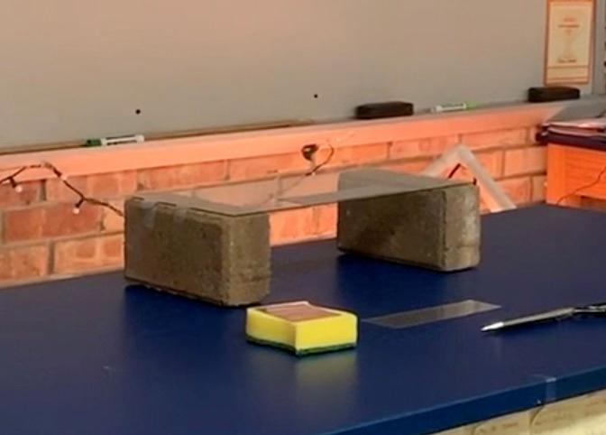
  Go over to the laser cart and turn on the laser by clamping the clothespin down over the “on” button. | 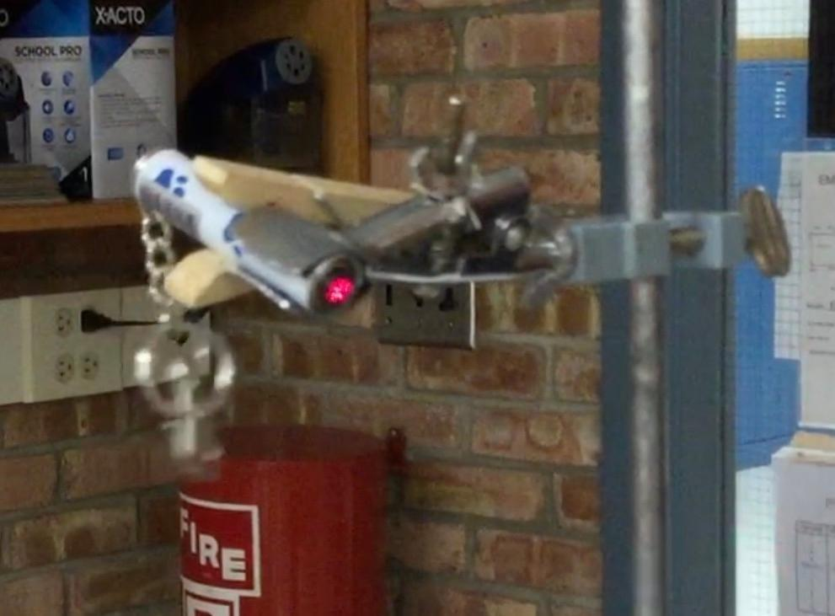
  Move the cart and position the laser so that the laser dot is hitting the top of the sponge on the table. | 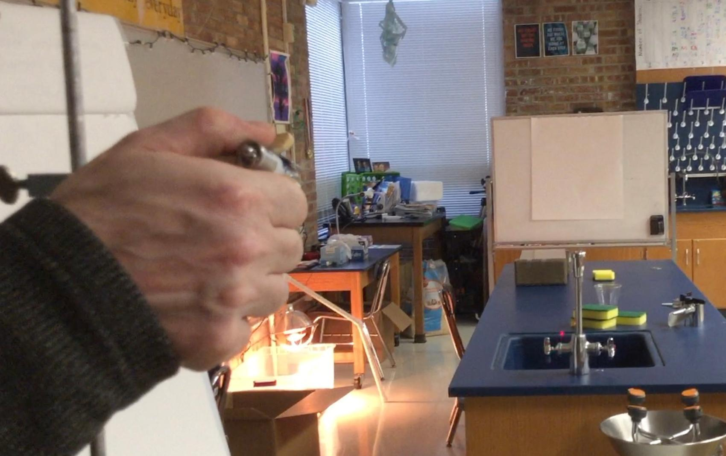
  Put a piece of the stick-on mirror material on the center of the sponge. Show that when you push on the sponge, the stick-on mirror material remains stuck to the surface and moves as the sponge moves, tilting a different way depending on how the shape of the sponge surface changes. Move the sponge as needed so that the laser is shining on the stick-on mirror material.
  The reflected laser dot should bounce off the stick-on mirror material and appear on the opposite wall or a whiteboard on or near the chart paper you put up ahead of time. Move the chart paper if needed so the reflected laser dot shows up on it.
  Encourage students to line up along the path of the reflected laser light so everyone can see the dot on the chart paper. Tell them to be careful not to block the laser light for the next tests. Explain that you are going to push on the sponge to make its surface bend and change shape, and you want them to watch what happens to the dot on the chart paper. Push down on the sponge with your hand.
  Demonstrate both cases, first by dropping a golf ball on top of the sponge. Make sure you drop it to the side of where the laser beam is shining so as not to have it fall or bounce up through its path. Have students describe what happened to the laser dot on the chart paper when you did this. They should say it moved. | 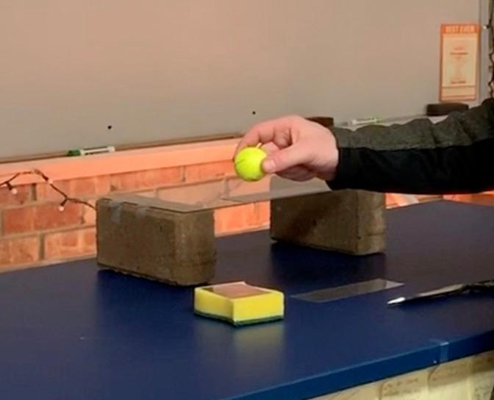
  Next, put a weighted cup on the sponge, again, out of the path of the laser. Ask students what it did to the laser dot. Students should say it made the dot move. Ask them what the downward push from the weight of the cup did to the shape of the sponge. Students should say it bent or compressed it. | 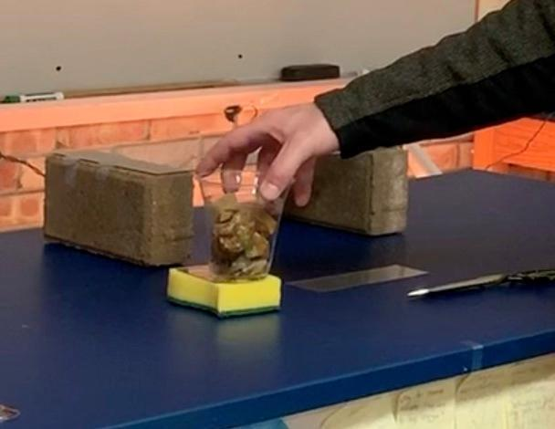
  Suggested prompt | Sample student response
  So what does the laser dot do when the mirror moves or tilts due to shape change in the object it is stuck to? | It shifts position.
  Let’s get ready to stick the mirror material to a piece of glass. If we then push on the piece of glass or the table by dropping something on either or resting a weight on either, what would we see happen to the laser dot if the object underneath the mirror bends or changes shape? | The laser dot will shift position.
  What if those objects don’t bend or change shape? | The dot won’t move.
  Shift the laser or the bricks and glass so the dot is now hitting the stick-on mirror material on the glass laying across the two bricks. Optionally, tape the glass to one or both bricks for more stability. The laser dot should bounce off the mirror material and show up on the chart paper. Smooth out the mirror material if the dot isn’t concentrated in one spot on the paper. | 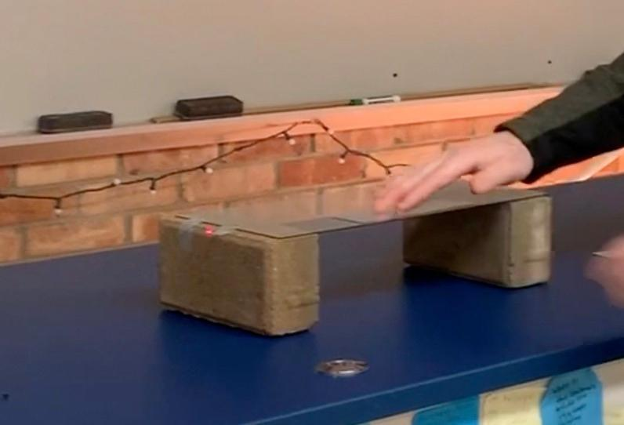
  From 1-2 inches above the glass, drop a golf ball on the side of the glass that is out of the way of the beam of the laser dot. Make sure not to drop it from a height greater than 1-2 inches to avoid shattering the glass. Have students describe what happened to the dot. | 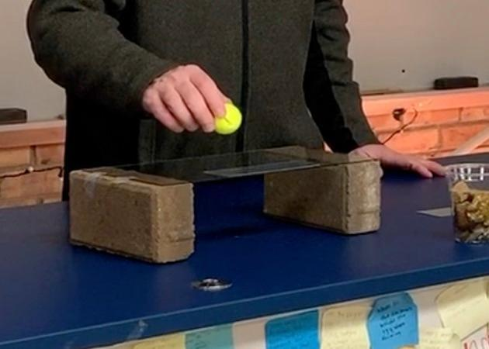
  Emphasize that this might be evidence of the glass bending or it just might be evidence of the mirror and glass bouncing a bit. Say that keeping the mirror and glass from bouncing might help us better determine if the glass is actually deforming. Have a student mark the bottom edge of the laser dot on the chart paper. Explain that this is so we can see if it moves from that position after we put something on top of the glass. | 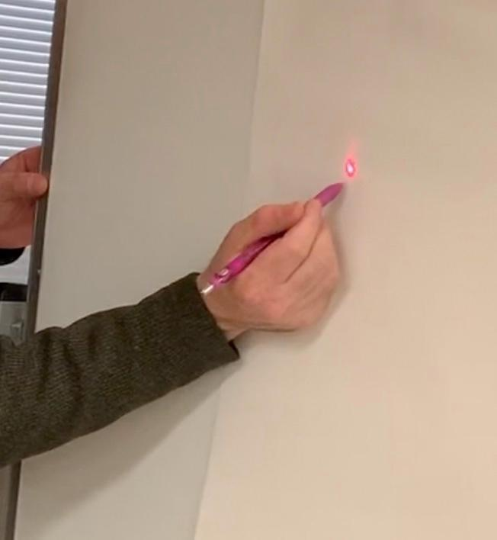
  Place a cup half-filled with rocks in the middle of the glass but out of the way of the laser beam. Explain that the weight of the rocks resting on the glass will apply a force to the glass. Have a student mark the bottom edge of the laser dot and report if it moved from the previous position. They should say yes. | 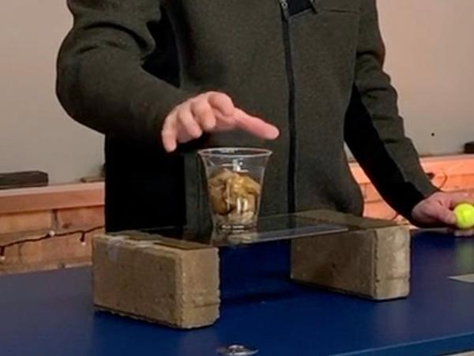

5 · MAKE PREDICTIONS AND ANALYZE CONCRETE LOAD TESTING PHOTOS | 4 min
MATERIALS: science notebook
Organize students in a semicircle around the projected slides. Project slide L. Say, We have figured out something about how glass behaves when a force is applied to it from something else making contact with it, but what about something like the floor that is made from a material like concrete?  Make predictions. Ask students the question on the slide and take a poll. Use a quick count of thumbs up and thumbs down to check student predictions. Direct students to write “concrete joint timelapse video” as our last data source on the last empty blank in the “Data source” column of their handouts.  Analyze the results from the concrete testing. Display slide M. Tell students that the images they will be analyzing were from a video of engineers testing how a concrete joint responds to different amounts of contact force applied to it. Explain that they are going to see timelapse of a video from such a test where engineers slowly increase the amount of downward force applied to the concrete joint and then observe how the joint responds. The timelapse was sped up 64x from the original speed so we can see if any changes occurred in a shorter period of observation time rather than watching the entire test in real time.  Have students look for changes in the video. Before pressing play say, As the video plays, the engineers are applying a greater amount of downward force. Watch closely so we can see if there is any change in shape associated with the force they are applying to the joint. Start the video https://youtu.be/MVkmrGJBQAo and allow the video to play once in entirety. Ask students if they want to see any of the video again, and replay if students wish to see it a second time. Give students a chance to record their observations on their handouts.  Say, OK, we’ve seen the results from applying more and more contact force to a concrete joint. Go back now and evaluate all the data we’ve collected on the handout to determine if any of it supports or refutes your initial claim. Even if we were in disagreement at the start of the period, all the different data we analyzed should provide us adequate evidence to evaluate those initial claims and, if needed, revise them so we are all in consensus on what common claim we can now all make about our original question. | ✱ SUPPORTING STUDENTS IN DEVELOPING AND USING STABILITY AND CHANGE  Previous to this activity, students have looked at collisions by slowing down the interactions. So far collisions have occurred too quickly to see without slowing them down. Now, students are looking at changes over time that are happening very slowly, and some of these changes could not be perceived without speeding up the process.  Students have had experiences with slow change over time before, such as the rate of plate movement in OpenSciEd Unit 6.4: What causes Earth’s surface to change? (Everest Unit). They also determine that large sections of rock (in plates) can bend when large forces are applied to them. If students raise this idea, emphasize this connection to the entire class.

6 · EVALUATE AND REVISE INITIAL CLAIMS | 5 min
MATERIALS: science notebook, Claim and Observations Organizer
Display slide N. Have students open their notebooks to a clean page and write their initial claim. Give students time to answer the questions on slide W in their notebooks. Refer students back to their observations organizer on the handout to help them determine if the data support or refute their original claim and summarize how the evidence from our investigations helps support or refute their initial claim.✱  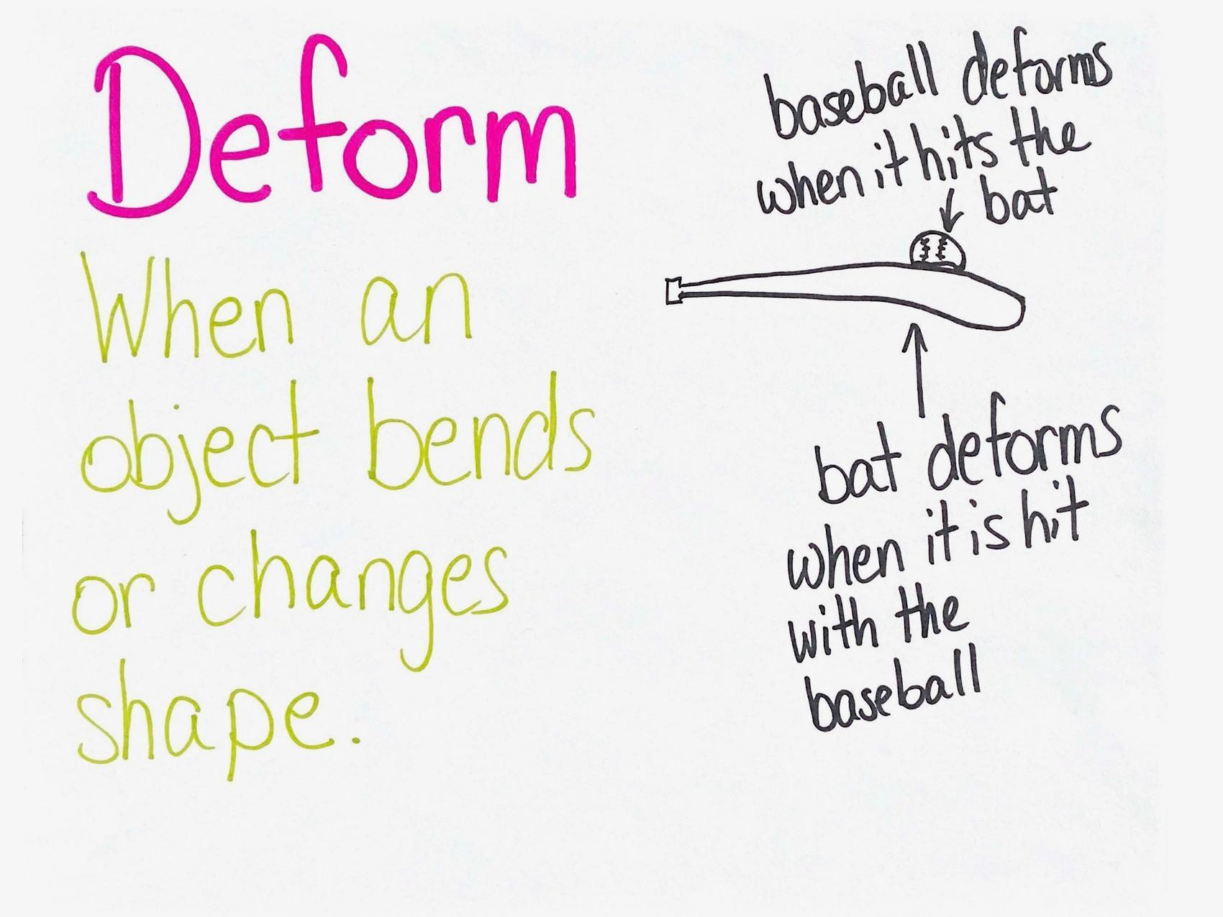  Introduce a new word. Say, We have been talking a lot about objects bending or changing shape. Scientists call this deformation. When an object bends or changes shape, it deforms.  Add deform to the Word Wall.✱ | ✱ SUPPORTING STUDENTS IN ENGAGING IN ARGUMENT FROM EVIDENCE  During the course of the lesson, students have engaged in investigations to determine if all objects bend or change shape in a collision. Students are now given the chance to go back and revise their thinking around their initial claim. By using evidence from the investigations, students reason why they support or refute their original claim.  ✱ ATTENDING TO EQUITY  Emerging Multilingual Learners: A Word Wall will become a useful space for recording a shared meaning of new words as students develop a deeper meaning for them. When developing new vocabulary, some strategies that may benefit emerging multilingual learners are to use student-friendly definitions, make connections to cognate words when possible, and include a visual representation of the word. Students may find it helpful to have you add additional images of objects deforming, both permanently and temporarily, next to the word deform on the Word Wall in the next lesson as well.
  ASSESSMENT OPPORTUNITY | Building towards: 3.A Construct and revise a written argument using evidence from various sources of data (slow-motion videos, photos, and firsthand investigations) to support or refute the claim that all objects do bend or change shape when pushed in a collision.  What to look/listen for: By this point in the lesson, students should provide evidence and support or refute their original claim to reflect that all objects do bend or change shape when pushed in a collision.  What to do: If students are not in agreement that all objects bend or change shape in a collision, observe what evidence the students have collected in their organizers to verify that the evidence was recorded correctly. If any evidence was not recorded accurately, have students review that part of the investigations and compare this with their evidence on their handouts. Ask students to refer to the evidence collected from the laser investigations and the concrete joint video to support or refute their original claim. All the observations made by students should provide evidence that the objects are changing shape or bending as a force is applied. The one exception would be the head of the golf club when it strikes the golf ball. But by the end of the lesson, students should be able to argue that it too may actually bend or change shape, but this may be occuring at too small of a scale for us to see in the video. If students are still struggling with this concept, pull up each video again at the start of the next lesson and/or go over the glass demonstration individually with students, making sure that they are observing that the objects are indeed changing shape when a force is applied. Pointing out the observations and helping students connect the observations to their claim will help students understand the key idea.

7 · NAVIGATION | 8 min
MATERIALS: science notebook
Poll students over concrete joint findings. Remind students of the images of the concrete joint that they have previously viewed. Point out that the object was seemingly very strong and rigid before the test, but it ended up deforming quite a bit before breaking. It deformed even though it appeared very solid and rigid at the start.

Display slide O to gather results on the poll for this question:
- How many of you were surprised by the results of the concrete joint test?

Have students give a thumbs up if they were surprised and a thumbs down if they were not surprised.
Say, The engineers applied more and more force to the joint, and it made it deform before it broke.

Display slide P to gather results on the poll for this question:
- Do you think that the concrete joint began to deform with a small amount of contact force at the start of the test or did it take a lot more force to start bending it?

Have students give a thumbs up if they think it started bending with a small amount of contact force applied to it and give a thumbs down if they think it didn’t start bending with a small amount of contact force applied to it and it needed more force before it started bending.

Say, We have seen how a sponge, a piece of glass, and a concrete joint behave when a force is applied to them. Let’s consider how all objects respond to any amount of forces applied to them, since ultimately we want to explain what happens in all collisions that causes objects to get damaged in some cases but not others.

Make predictions. Show slide Q. Have students discuss the two questions on the slide with a partner:
- Do you think applying any amount of force to any solid object would cause it to bend?
- How could we design an investigation like the engineers did with the concrete joint test to figure out if any amount of force would cause any solid object to start bending or change shape?

After discussing these questions, say, I am interested in hearing what you all think. Let’s plan to share the ideas you discussed with your partner and also make a plan to investigate your ideas further in our next class.

